

Somerset Patriots Lineup Optimizer & Hitting by Pitch Type
  - A simplified method to optimize the Somerset Patriots lineup vs left-handed and right-handed pitchers by projected runs scored. Exposing hitting performance by pitch types graded by Baseball Savant and Fangraphs.

By: Patrick Holsey
Date: June 9, 2025

Abstract
This report analyzes hitting performance via on-base percentage and slugging percentage versus starting pitchers over 56 games played by the Somerset Patriots in the 2025 regular season. The analysis completed in this report aims to determine optimal batting lineups versus left-handed and right-handed starting pitchers as well as organize hitting performance against scout-graded pitch types. The two applications created in this analysis are available online via the below links at Shinyapps.io:
Somerset Patriots Optimal Lineups
Somerset Patriots Batting by Pitch Type and Scout Grade

Table of Contents
Abstract ii
Table of Figures iii
1. Introduction 1
2. Literature Review 1
3. Data Collection 2
4. Actual Team Results 3
5. Application Methodology and Results 4
5.1 Optimal Lineup: Application Creation 4
5.2 Optimal Lineup: Application Features 5
5.3 Batter Performance against Graded Pitch Types: Application Creation 9
5.4 Batter Performance against Graded Pitch Types: Application Features 9
6. Conclusions 10
7. Limitations/Future Recommendations 11
Appendix 12
References 13

Table of Figures
Figure 1: Actual Runs Scored by Starting Pitcher Handedness 3
Figure 2: Team Statistics, OBP, and SLG 4
Figure 3: Optimal Lineups based on Projected Runs Scored 6
Figure 4: Updated Projections after Replacement 7
Figure 5: Replacement without Minimum 8
Figure 6: Batting by Pitch Type and Scout Grade (unfiltered) 9
Figure 7: Batting by 55 Graded Curveball (sorted) 10

1. Introduction
Through 56 games of the 2025 regular season, the Somerset Patriots (double-A affiliate of the New York Yankees) have a losing record of 25 wins and 31 losses. This record ranks 5th out of 6 teams in Northeast Division of the Eastern League and is unlikely to win the first half in the division. The Patriots have endured several key player injuries and a lack of offensive production which have contributed to a -10 run differential of 251 runs scored compared to 261 runs allowed.
The purpose of this report is to evaluate and analyze the successes and failures of various batting lineups used against left-handed and right-handed starting pitchers, ultimately leading to the development of an application that creates an "Optimal Lineup" for each scenario in terms of runs scored projections. In addition, a second application will show each player’s on-base percentage (OBP) and slugging percentage (SLG) against six different pitch types graded 50-65 by Baseball Savant and Fangraphs scouting. The main objective of these applications is to increase the team's scoring by positioning each player in their ideal spot for success. By producing more runs, the Patriots aim to contend for the Northeast Division title in the second half of the season and potentially replicate their appearance in the Eastern League Finals from 2024.

2. Literature Review
This report used the following resources to determine a fair projection of runs scored by batting order:
Morong, C. (2006). “Value of OBP and SLG by Lineup Position.”
In this fan post, the author created a regression of team runs per game as the dependent variable with OBP and SLG of each lineup slot as independent variables for MLB regular seasons from 1989-2002. The author found that the lineup slot determined the weighted coefficients for OBP and SLG - for example, one point of OBP is worth about .003 runs per game for the leadoff hitter and only about .001 runs per game for the hitter in the 8th slot. Without getting too far into the weeds of testing for multicollinearity, the author calculated that the “variance inflation factor” was never above two. This factor aligned with the average number of plate appearances per starting pitcher. This contributed to the simplified formula used to calculate projected runs per game, outlined in section 5: Application Methodology and Results.
Arneson, K. (2006). “Must. Bat. Kendall. Ninth.”
The author expanded upon the formula used in “Value of OBP and SLG in Lineup Position” by creating a script to calculate each player’s OBP and SLG for every possible lineup permutation for one team. In line with the analysis described in section 5: Application Methodology and Results, players were assigned a lineup position based on their performance in that specific slot rather than their “typical” lineup position. For example, a fast leadoff hitter or a power-hitting cleanup might be evaluated differently based on their performance in various slots.

3. Data Collection
Data was manually collected from MiLB.com for 56 game logs spanning from April 4 to June 8, 2025. Originally, the datasets included only 50 games logs, however it was expanded to 56 game logs based on the recent emergence of Roc Riggio. I created separate datasets for offensive and defensive statistics. The offensive statistics gathered include the following: batter name, batting order, number of outs (excluding sacrifice flies), singles, doubles, triples, home runs, walks, hit-by-pitch, and sacrifice flies. For the defensive statistics, I recorded the following: pitcher name, throwing hand, earned runs, innings pitched and defense positions of the lineup. Pitch types including: fastball, curveball, slider, changeup, cutter, and splitter, with scouting grades of 50 and above, were manually collected from individual player pages on BaseballSavant.mlb.com and Fangraphs.com.
Baseball-Reference.com defines OBP as “On-Base Percentage is a measure of how often a batter reaches base. It is approximately equal to times on base via (hits + walks + hit-by-pitch) divided by plate appearances” (2024). To calculate a player's plate appearances (PA), I first counted the number of at-bats. At-bats are determined by adding together each instance of an out (excluding sacrifice flies), as well as singles, doubles, triples, and home runs. I then added walks, hit-by-pitch occurrences, and sacrifice flies to at-bats to arrive at the total number of plate appearances. MLB.com defines SLG as “Slugging percentage represents the total number of bases a player records per at-bat. Unlike on-base percentage, slugging percentage deals only with hits and does not include walks and hit-by-pitches” (2025). The formula to calculate SLG percentage is: (singles + doubles*2 + triples*3 + home runs*4) divided by at-bats.

4. Actual Team Results
In an R script, I calculated the total number of games played, earned runs, and innings pitched grouped by opposing starter pitching hand, as well as the average runs per game, as shown in Figure 1.
Pitching Hand | Games Played | Earned Runs | Innings Pitched | Avg Runs/Game
Left | 15 | 20 | 68.1 | 1.33
Right | 41 | 92 | 173 | 2.24
Figure 1: Actual Runs Scored by Starting Pitcher Handedness
Next, I calculated the average number of plate appearances per starting pitcher, which is just above 18. Each player's at-bats and plate appearances were grouped by batter name, starting pitcher’s hand, and lineup position/order number. Individual OBP and SLG averages were calculated using the formulas mentioned earlier and grouped by pitching hand and order number. A snippet of this updated dataset is provided in the Appendix, Table A.
To compare optimal lineups to actual team performance, I summed team statistics and calculated team OBP and SLG by pitching hand as shown in Figure 2.
Pitching Hand | Total Hits | Total Walks | Total Plate Appearances (PA) | Total Bases | Team OBP | Team SLG
Left | 56 | 29 | 287 | 91 | 0.314 | 0.361
Right | 146 | 64 | 728 | 259 | 0.304 | 0.400
Figure 2: Team Statistics, OBP, and SLG
I calculated the projected team runs scored by starting pitcher hand using the formula: Team OBP multiplied by Team SLG, then multiplied by 18, which represents the average number of plate appearances per starter. The projected runs scored per left-handed starter is 2.04, compared to the actual figure of 1.33. For right-handed starters, the projection stands at 2.19, while the actual runs scored is slightly higher at 2.24.
Actual player results versus starting pitch types—fastball, curveball, slider, changeup, cutter, and splitter—are presented in a filterable and sortable application detailed in section 5.3. Snippet of Batting summary by pitch type and scout grade available in Appendix, Table B.

5. Application Methodology and Results

5.1 Optimal Lineup: Application Creation
To create optimal lineups against left-handed and right-handed starters, I first calculated the projected runs scored per player for each lineup slot they occupied over the 56 games. Like the projected team runs scored formula discussed in section 4, I calculated each player’s average OBP and multiplied it by their average SLG, which had been grouped by the starter’s handedness and the player’s lineup slot. The resulting total is then multiplied by two PA per player, based on the fact that the team averages 18 PA against a starting pitcher. The optimal lineup was created by selecting the top player (highest projected runs scored) for each lineup position, repeating this process until the lineup was complete. Creating the optimal lineups proved to be a trial-and-error process, as some players had only two PA in their lineup slots, despite being chosen based on their potential to score the highest number of runs. To address this, I established a minimum of six PA for left-handed pitchers and eight PA for right-handed pitchers. Additionally, I removed MLB players on rehab assignments—Jazz Chisholm Jr. and DJ LeMahieu—from both the optimal lineup and bench selections.

5.2 Optimal Lineup: Application Features
- Web link to application: Somerset Patriots Optimal Lineups
- Player statistics shown: Name, Avg OBP, Avg SLG, PA in the respective lineup slot, and defensive positions played by each player.
- Optimal Lineups created using a minimum of 6 plate appearances vs left-handed starters and 8 plate appearances vs right-handed starters in each lineup slot.
- Available Bench Players shown below Optimal Batting Order along with their defensive positions
- Drop-down selections available for Pitcher Handedness, Order number to replace, and Bench players available. “Update Lineup” button used to replace a current player in the Batting Order.
- Optimal Lineups are set as default for Pitcher Handedness = L and Pitcher Handedness = R
  - The optimal lineup vs left-handed starters is projected to score 2.26 runs
  - The optimal lineup vs right-handed starters is projected to score 3.26 runs

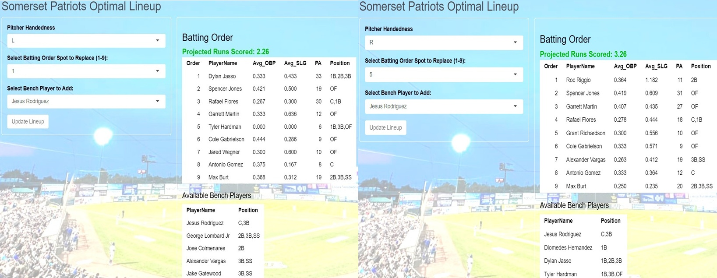
Figure 3: Optimal Lineups based on Projected Runs Scored

- Projected Runs Scored automatically updates when a player is replaced, based on his statistics from that lineup slot. In below example, George Lombard Jr replaced Spencer Jones in the 2nd slot against a right-handed starter. Projected Runs Scored turns red as it lowers to 2.85 from Optimal Lineup’s 3.26 Runs Scored.
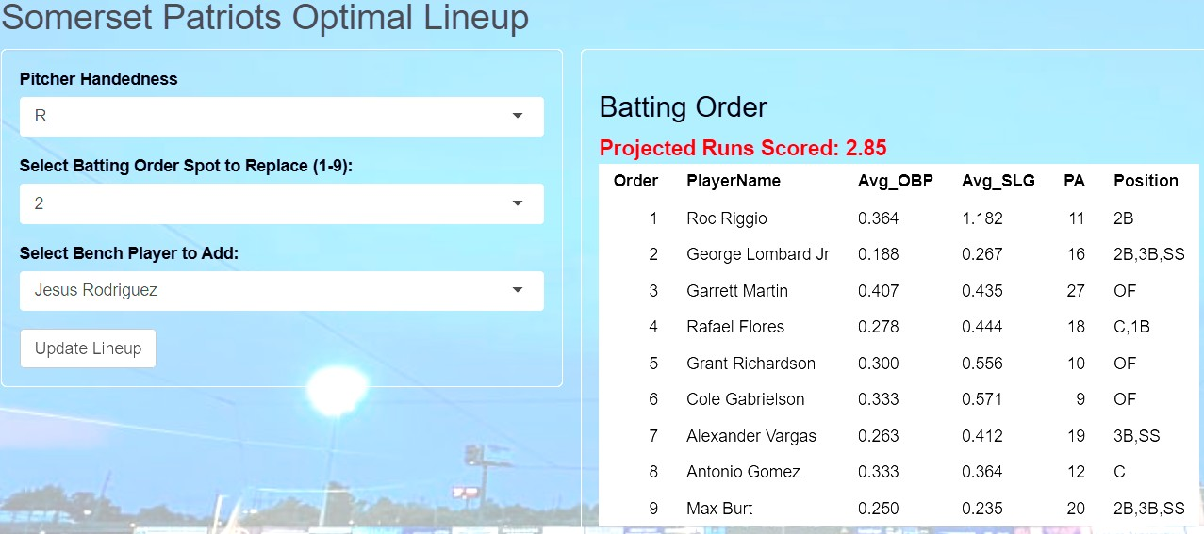
Figure 4: Updated Projections after Replacement

- Replacing a player removes the required minimum plate appearances. For example, Tyler Hardman is the only batter in the 5th lineup slot vs left-handed starters to accumulate 6 plate appearances. He is replaced with Coby Morales below who increases the projected runs scored, but only accumulated 4 plate appearances in the 5th lineup slot vs left-handed starters.

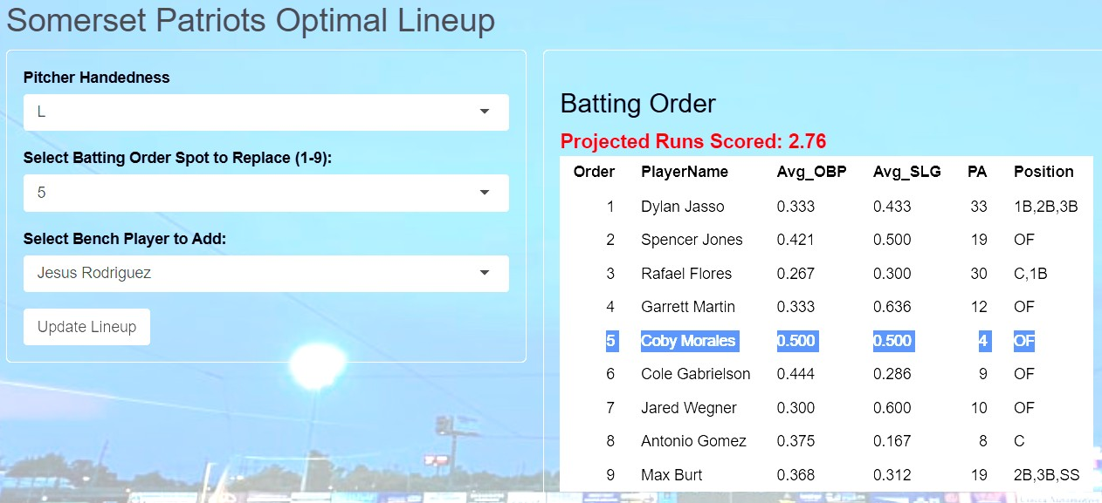
Figure 5: Replacement without Minimum

5.3 Batter Performance against Graded Pitch Types: Application Creation
To create batter performance against left-handed and right-handed starters with pitch types graded 50 and above, I joined the pitcher dataset to the batter dataset by Pitcher Name and Pitcher Hand. I filtered out results where the starting pitcher did not have a scouting grade posted on Baseball Savant or Fangraphs. Next, I calculated each batter’s average OBP and average SLG against left-handed or right-handed starting pitchers with graded pitch types. Additionally, I removed MLB players on rehab assignments—Jazz Chisholm Jr. and DJ LeMahieu—from the Batting by Pitch Type table.

5.4 Batter Performance against Graded Pitch Types: Application Features
- Web link to application: Somerset Patriots Batting by Pitch Type
- Player statistics shown: Name, Pitcher Hand, Pitch Type, Scout Grade, PA, Avg OBP, and Avg SLG.
- Drop-down selections available for Pitcher Handedness, Pitch Type, and Scouting Grade.
- Application includes player name search at the top.
- Each table column is sortable by highest to lowest or vice versa.
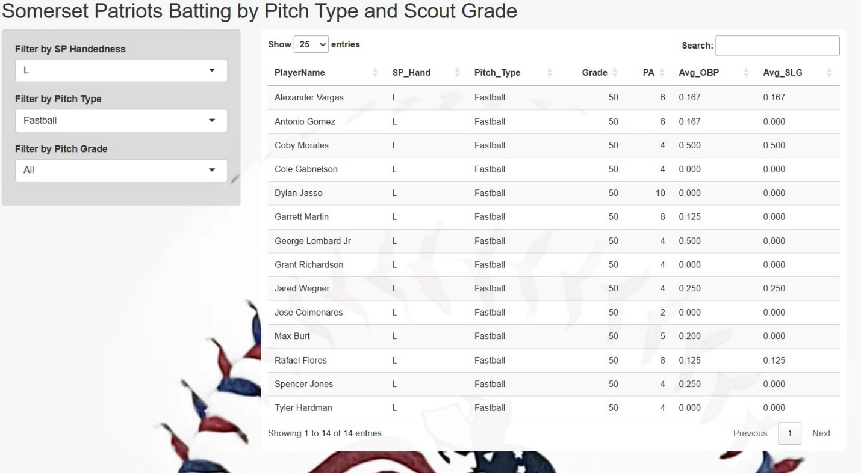
Figure 6: Batting by Pitch Type and Scout Grade (unfiltered)
- Example below shows Batter Performance by Pitcher Hand = R, Pitch Type = Curveball, and Scout Grade = 55 sorted by highest to lowest Avg OBP.
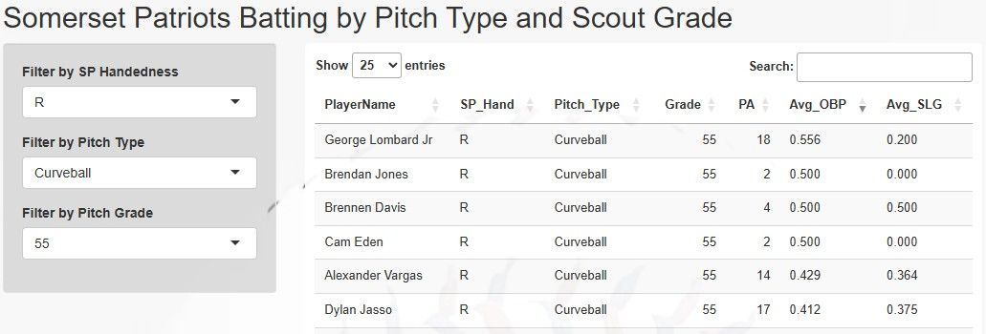
Figure 7: Batting by 55 Graded Curveball (sorted)

6. Conclusions
Statistical repositories, like MiLB.com, offer a player’s overall OBP, SLG, and PA, however this analysis digs deeper by breaking down these statistics by batting lineup position and pitch type. Utilizing the Optimal Lineup application along with the Batting by Pitch Type and Scout Grade application, can offer the Somerset Patriots' managerial staff valuable information. These statistics will help them make informed decisions about how to create a batting lineup that potentially generates the most runs using a simplified formula. The projected average runs scored for the Optimal Lineup against left-handed starters is 2.26, which is higher than both the team's projected runs of 2.04 and the actual average runs scored of 1.33. The projected average runs scored for the Optimal Lineup against right-handed starters is 3.26, which is higher than both the team’s projected runs of 2.19 and the actual average runs scored of 2.24. By applying the optimal lineup and adjusting matchups by pitch type, the Somerset Patriots could turn their run differential to a positive number and increase their chances to win the second half of the Northeast Division in 2025.

7. Limitations/Future Recommendations
The data used in this analysis covers only a limited number of games—specifically, 56 during the first half of the Somerset Patriots' 2025 regular season. This data was collected manually, making it susceptible to typographical errors. One significant challenge was the variation in lineups, particularly against left-handed pitchers, who are faced less frequently. This variation resulted in difficulties in achieving the required minimum number of plate appearances. As illustrated in the optimal lineup against left-handed pitchers, Tyler Hardman is the only batter who qualified for the 5th lineup slot in this context. Despite having zero runs scored from that position, his performance remains the best option, as other players have higher runs scored totals from different lineup slots.
Future studies should incorporate data from additional games to enhance the matchup scenarios as illustrated in this study. To improve the projected runs scored formula, I recommend conducting batted ball regressions using advanced metrics such as weighted Runs Created Plus (wRC+), weighted On-Base Average (wOBA), and Runs Above Average based on the base/out states (RE24). This approach should be considered if such data becomes available on Minor League Baseball websites.

Appendix
Table A: Average OBP and SLG grouped by pitching hand and order number
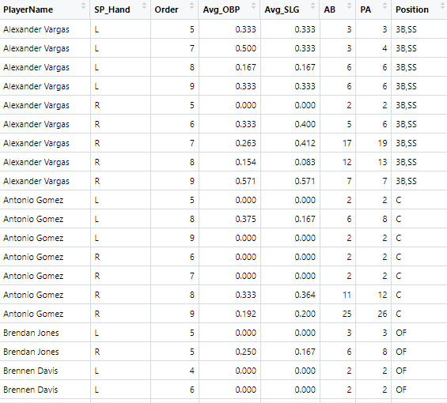
Table B: Average OBP and SLG grouped by pitch type and scout grade
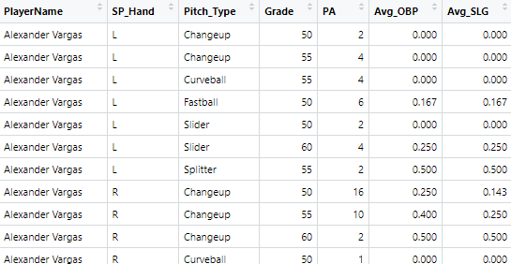

References
Arneson, K. (2006). “Must. Bat. Kendall. Ninth.”
https://catfishstew.baseballtoaster.com/archives/322075.html
Baseball-Reference.com. (2024). “On base percentage.”
https://www.baseballreference.com/bullpen/On_base_percentage#:~:text=On%20Base%20Percentage%20(aka%20OBP,has%20hit%20a%20sacrifice%20fly.&text=There%20is%20also%20an%20Adjusted,league%20average%20for%20that%20year.
BaseballSavant.mlb.com. (2025). “Player Standard Pitching Statistics – Scouting Report.” Example:
https://baseballsavant.mlb.com/savant-player/jonah-tong-804636?stats=career-r-pitching-milb
Fangraphs.com (2025). “Player Statistics – Prospects Report.” Example:
https://www.fangraphs.com/players/jonah-tong/sa3022324/stats?position=P
MiLB.com. (2025). “AA Eastern League Standings.” https://www.milb.com/somerset/standings/

MiLB.com. (2025). “Gameday Box Scores and Play-by-Play.” Example:
https://www.milb.com/gameday/patriots-vs-yard-goats/2025/04/04/783416/final/box

MLB.com. (2025). “Slugging Percentage (SLG).”
https://www.mlb.com/glossary/standard-stats/slugging-percentage

Morong, C. (2006). “Value of OBP and SLG by Lineup Position.”
https://www.beyondtheboxscore.com/2006/2/12/133645/296

